****Project Plan of COMP2003HK

**Web and App Development Solution**

**[Date: 19 Jan 2023]**

Group 7

Presented by:

KWOK KA KIT (Scrum Master)

YIP KIN WANG (Technical Manager)

NG KA WAI Davina (Product Owner)

TABLE OF CONTENT

1. Project Vision
2. A List of Project Objectives
3. User Stories
4. Use case Diagrams
5. UML Diagrams
6. An initial sprint plan
7. A risk management plan
8. A communication plan
9. The current prototype that shown during Marketplace demo
10. The progress up until the marketplace demo
11. Project Vision

To help the client to improve the usability and navigability of ebird website, this document offers some helpful information and best practices for website and android application development. It also suggests a standardized and user-friendly user interface for the client to record the species and the surveyor to share information dissemination through websites.

1. A List of Project Objectives

The project aims to:

a) Arouse and enhance public and expert the awareness of the

use of Hong Kong Bird Zone database;

b) Promote public understanding of the importance of protecting the rare birds;

c) Encourage public participation in recording the bird habits and contribute the Hong Kong Bird Zone database;

d) Provide a platform for view, exchange information with bird lovers;

e) Provide rare bird database for education sectors and public; and

f) Keep the public abreast of the latest news and activities related to the Hong Kong Bird Zone website.

1. User Stories

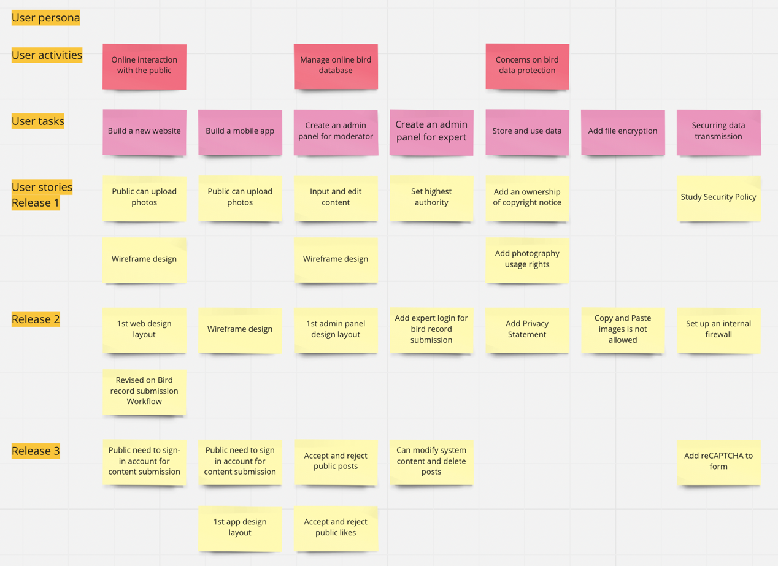

1. Use case Diagrams

Admin use case

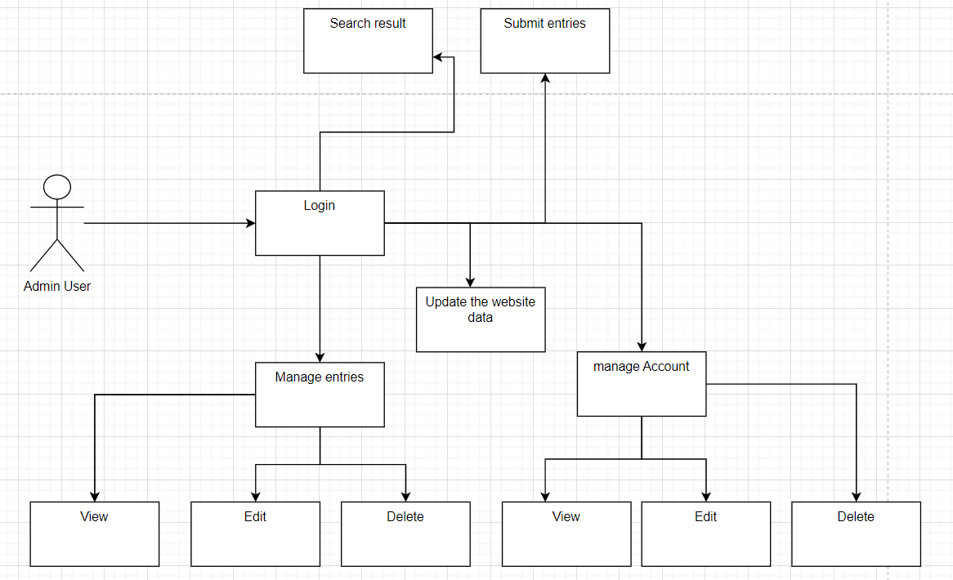

Public use case

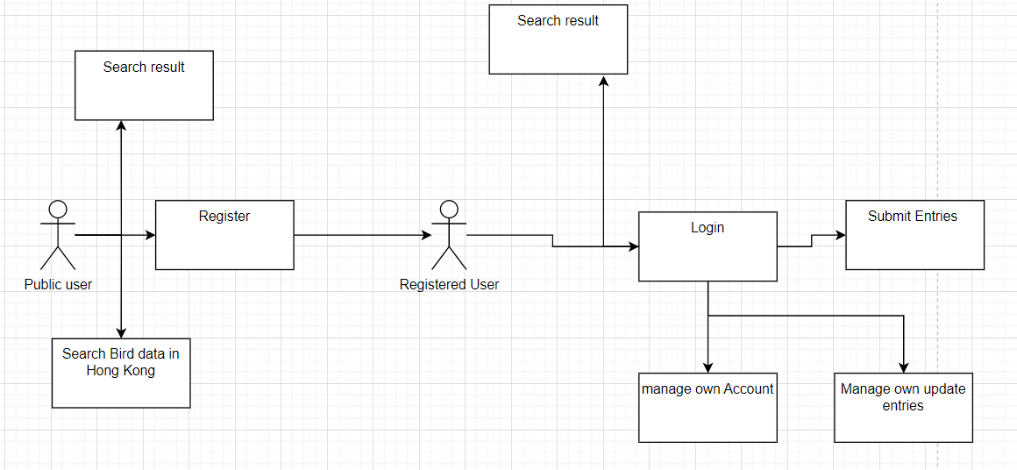

Researchers use case

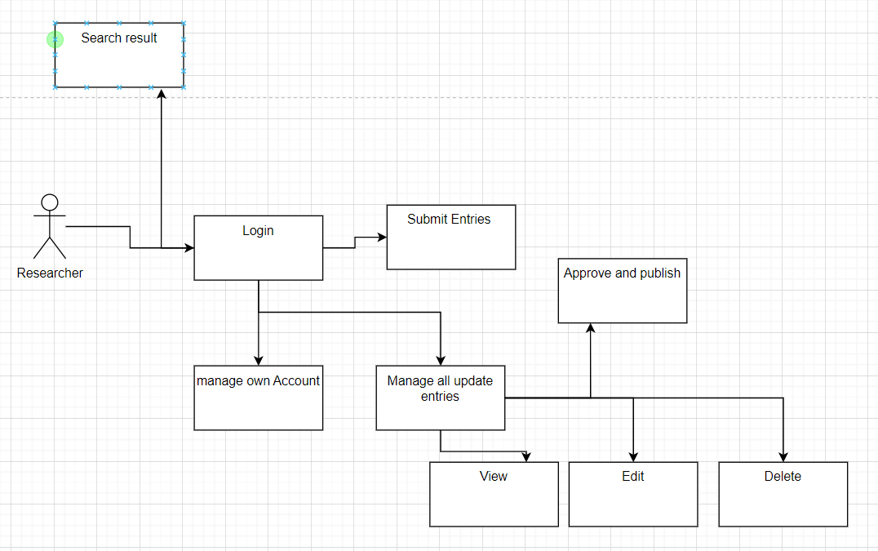

1. UML Diagrams
2. An initial sprint plan

The responsibility of the Scrum Master is to keep the high-level product view constantly. Instead of serving as a high-level, strategic plan development of the products, the roadmap will become an overstuffed product backlog if it places too much emphasis on the features. During the project planning stage, get as much user requirements as possible, conducted focus group to identify client needs. The plan serves as a reminder to stay rooted in the long-term goals.

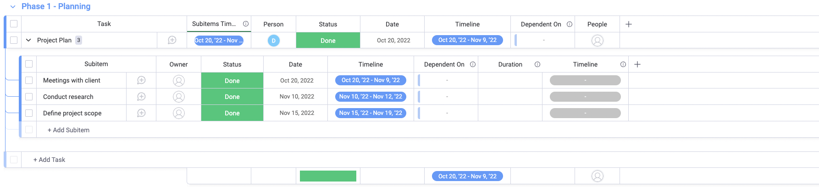

Project plan will be delivered in the Planning stage. A project plan that lists the project's phases and checkpoints, tasks, dependencies, the deliverables, the start and end dates for each phase and task on the schedule. It is also necessary to provide current environment description, requirements specifications and a team formation milestone.

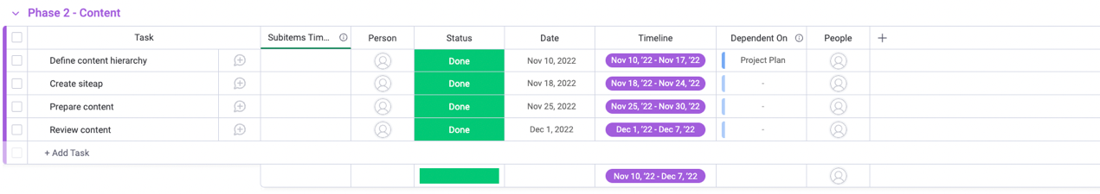

Based on the user stories (Release 1) in previous stage, the product backlog is formed. Project stakeholders continue to communicate and refine the user ideas before turning it into website design layout on next stage. There are several defects, issues, and user stories in the product backlog (informal, natural language descriptions of one or more desired features, often written from the perspective of your actual users).

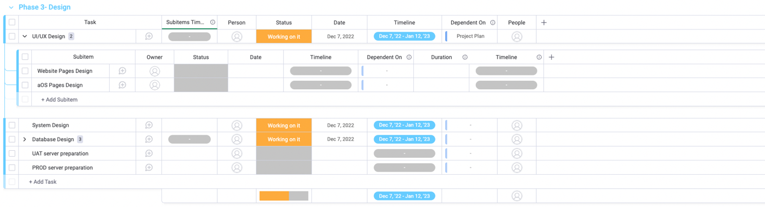

Based on the user stories (Release 2) in previous stage, first design will be provided to client after requirement gathering and content review with the client. When the basic functions and features is confirmed, the design team starts the mobile app wireframe design and the first design of website front-end will be released. Database design is fine-tunning by communicating the workflow with the client. When the coding style is confirmed, technical lead is going to plan the server specifications and server preparation.

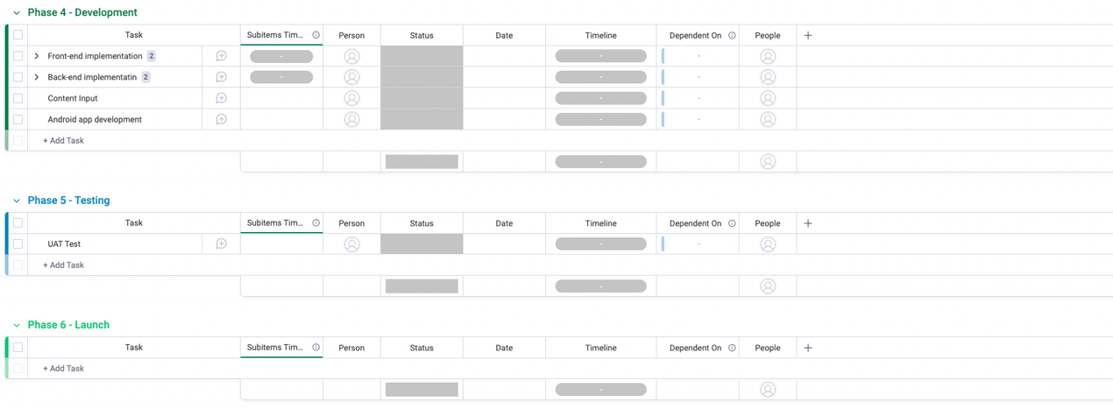

Based on the user stories (Release 3) in previous stage, the development features and functions should be in line with the design proposed in Design stage. Deliverables in this stage included Program codes / Software modules. Technical team will also work on the website plug-in configuration.

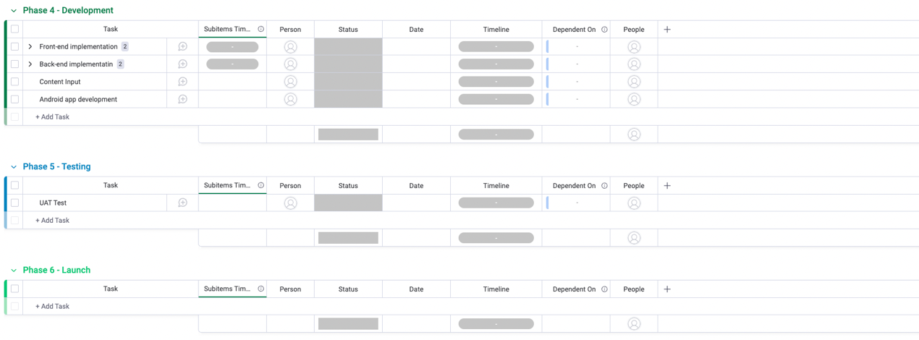

In this stage, the team designs and prioritizes tests. The team creates ideas on how to enhance the experience as well as methods to test those ideas for each opportunity or problem that is found. Acceptance test plan, specifications and results will be delivered. The team creates a testing procedure and key performance metrics for each hypothesis (KPIs). The list of prospective tests is prioritized after it has been created using two factors: potential business impact and simplicity of implementation. Ideas that have been given higher priority are tested first in front of the rest of the queue. The team conducts testing in one- to two-week "sprints" to confirm that the suggested methods are effective.

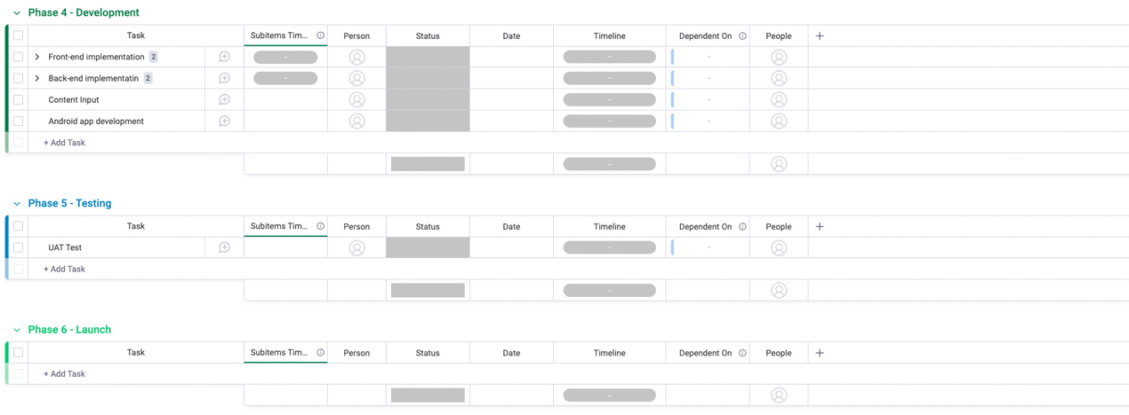

After website production launched, instead of assumptions, receives clients’ feedback is important. Scrum Master prepare a project evaluation report for project closure. The Project team will deliver organization responsible for providing a high quality applications support and maintenance service to the client.

1. A risk management plan

When designing a framework for risk management, at least five essential elements must be taken into account. They are risk governance, risk reporting and monitoring, risk reporting and assessment, risk mitigation, and risk identification. All project risks should be managed through a formal process that includes a process to mitigate or eliminate negative impacts to the project, as well as develop contingency plans to lessen the impact on the schedule, scope or cost, if the risk should occur.

|  |
| --- |
| Project Management Team member |
| Scrum Master |
| Technical Lead |
| Product Owner |
| The Client |

|  |
| --- |
| Risk Priority |
| 3: High |
| 2: Medium |
| 1: Low |

|  |  |  |  |  |  |
| --- | --- | --- | --- | --- | --- |
| # | Issue | Risk | Risk Control | Responsibility | Risk Priority |
| 1 | The client is not familiar in handling website project | Poor communication with the project team | Assign single contact point or a small project team to the client that can be reached by the client anytime. | Product Owner, the Client | 2 |
| 2 | Client concerns if appropriate security measures is implemented. | Technical manager is not expert enough that leads to poor time management in the project and the project fail to meet the user requirements. | Technical Manager must acquire a certification of ISO27001 for information security management and/or ISO31000 certificate for risk management | Scrum Master | 1 |
| 3 | The network security level in not up to standard | DDOS from outsider | A network security mechanism known as a DMZ is added to secure an organization's local area network | Technical Lead | 2 |

Step 1: Risk Identification

Defining the risk is the first stage in determining the risks that the project confronts. Raise out if there is any risk issue is the potential harm to the project. Examples include lack of resources risk, operational risk, political risk, and regulatory risk, etc. Product owner can then choose the risks to which it is exposed and divide them into core and non-core risks after outlining all potential concerns, take core risks in order to boost performance and long-term success. Non-core hazards can frequently be avoided or eliminated because they are not necessary.

Step 2: Risk ranking

After identify the risk, create a risk table with risk ranking. Low risk means that there is just a slight chance that it will affect the project's objectives negatively and that there will only be a small amount of worry. A medium risk project is one that has an impact on the project's goals, budget, or schedule. The likelihood of it happening is high enough to justify tight control of risk factors causing it. When defined as high risk, it is thought to be very likely to happen and the consequences will be detrimental to the project's goals, budget, and schedule.

Step 3: Risk Measurement

Risk measurement is the process of figuring out the quantitative or qualitative value of a risk in relation to a certain circumstance and a known danger. Assessing risks entails calculating the likelihood that they may materialize which is known as the risk matrix calculation.

Step 4: Risk Mitigation

The client can then choose the risks to which it is exposed and divide them into core and non-core risks after outlining all potential concerns. Core risk must be taken in order to boost performance and long-term success. Non-core hazards can frequently be avoided or eliminated because they are not necessary.

Step 5: Risk Reporting and Monitoring

Based on the hierarchy of control the project team aligned with the client, type of project management methodology used, Scrum Master deliver report includes a risk overview reflecting existed risk, risk management steps implemented, and possible effects on budget, timetable, and deliverables.

1. A communication plan

The Communication Matrix is an evaluation tool created for anticipatorily planning communications on a project, to identify precisely how a person is speaking, and to offer a framework for figuring out rational communication goals.

Communication Matrix:

|  |  |  |  |  |  |
| --- | --- | --- | --- | --- | --- |
| # | Communication | Purpose | Medium | Frequency | Audience |
| 1 | Kickoff Meeting | Introduce project. Review objectives and goals. Gather user requirements. | In Person | Once | Project Stakeholders |
| 2 | Project Team Meetings | Review Project Status | In Person / Zoom meetings | Weekly | Project Team |
| 3 | Technical Manager, frontend developer and backend developer Meetings | Discuss, review frontend & backend design and preparation for development. | In Person / Zoom meetings | If needed | Technical team |
| 4 | Monthly Project Status Meetings | Update project progress and ensure smooth implementation of the system. | In Person | Monthly | Project Stakeholders |
| 5 | Project Deliverables | Deliver software modules / documentation | In Person / Submitted to the system | Monthly | Project Team |
| 6 | Action Items Follow up | Complete and review a certain task or activity at the end of each sprint | In Person/ Email / Zoom meetings | Bi-Weekly | Project Team |

Develop the scope statement

The scope statement is the formal document that identifies the deliverables included and excluded from a project. It may include the following sections:

* Project objective
* Deliverables
* Milestones
* Key requirements
* Limits and exclusions

Conduct stakeholder analysis

Stakeholder analysis is a technique used to evaluate people’s needs from and influence over a project. Stakeholder should be monitored in following priority

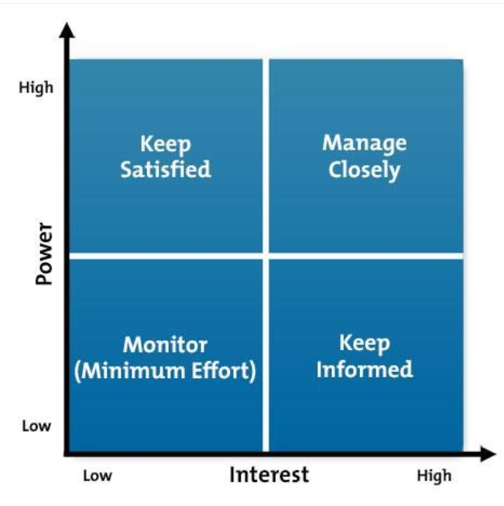

Establish and communicate the project plan

The project plan is the formal document that defines the project management processes that are used to execute and control the project

Review the work breakdown structure

The work breakdown structure in a visual format helps break down the project into small deliverables that can be added into a project schedule.

Keep track of actions, issues and risks

Keeping track of actions, issues, risks and key decisions is an administrative challenge, but it’s core to issue and risk management processes. We should write down and review your actions, issues and risks on a weekly basis, so we won’t forget any important item that needs a response.

Update the project schedule and review the critical path

It’s important to reinforce updating the project schedule on a timely basis. Schedule a specific regular time to do the administrative updates. Once the schedule is updated, we should examine the critical path to determine if any tasks that directly impacts a key milestone or a project completion date have slipped.

1. The current prototype that shown during Marketplace demo

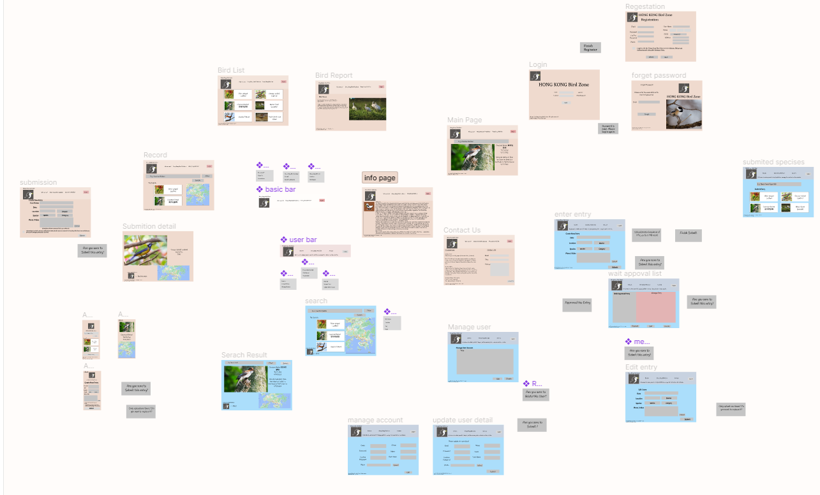

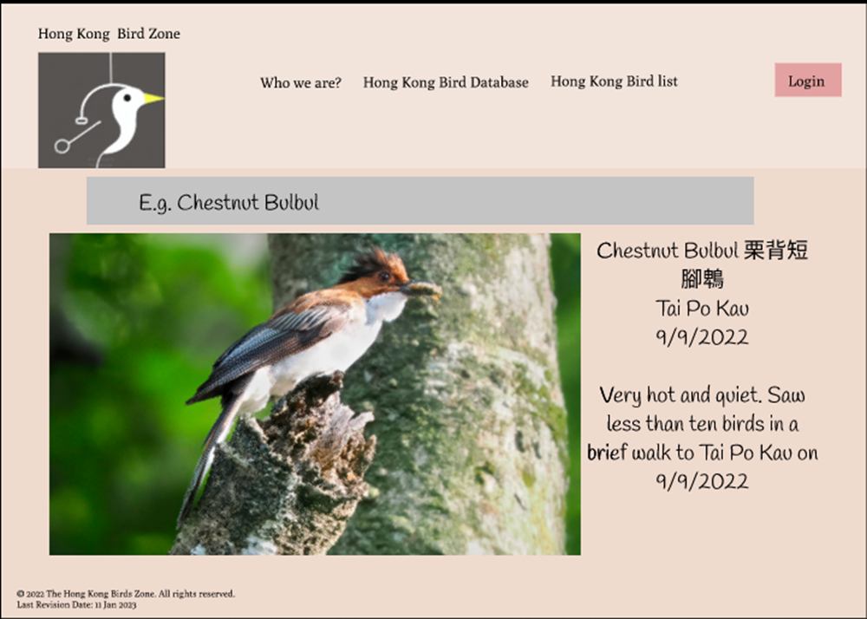

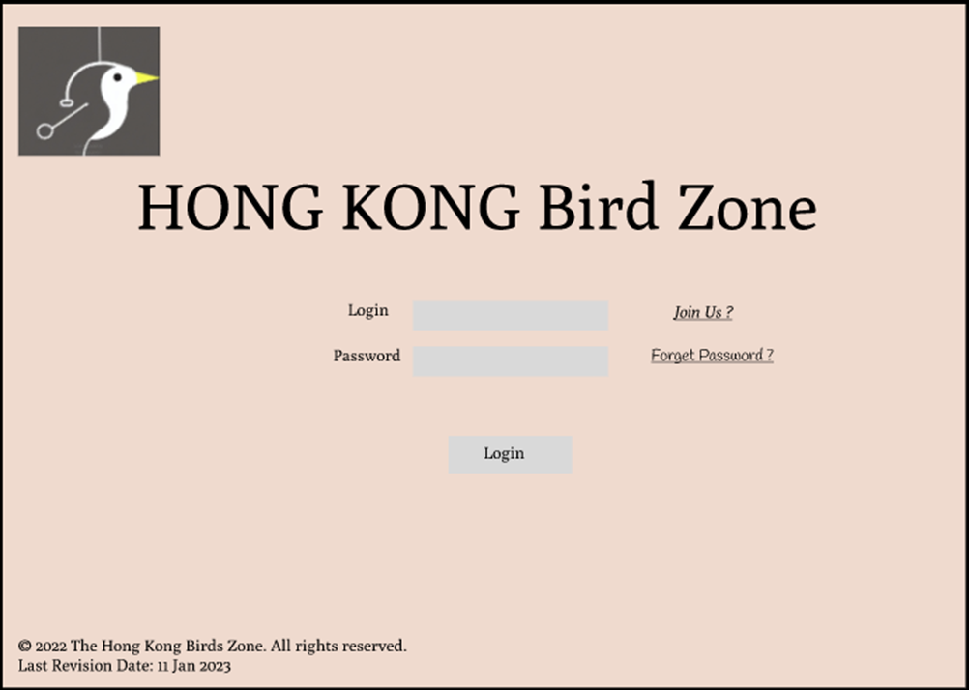

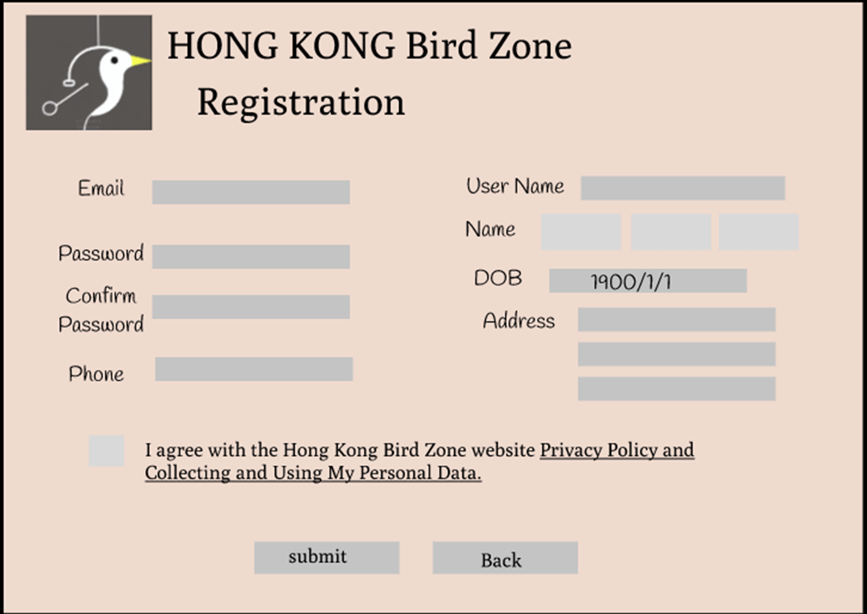

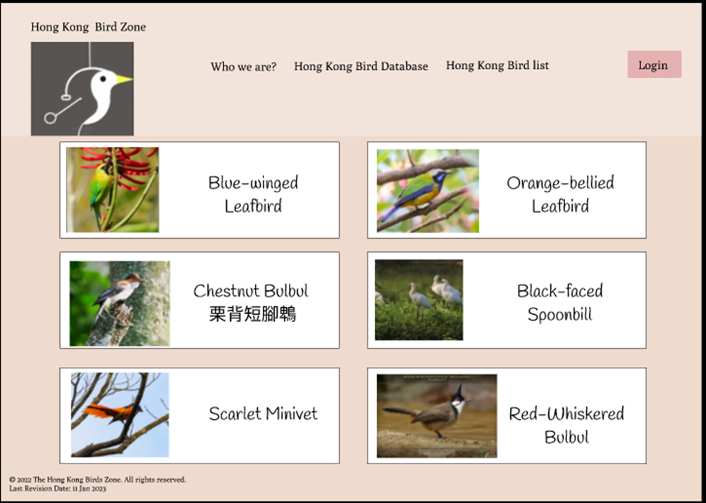

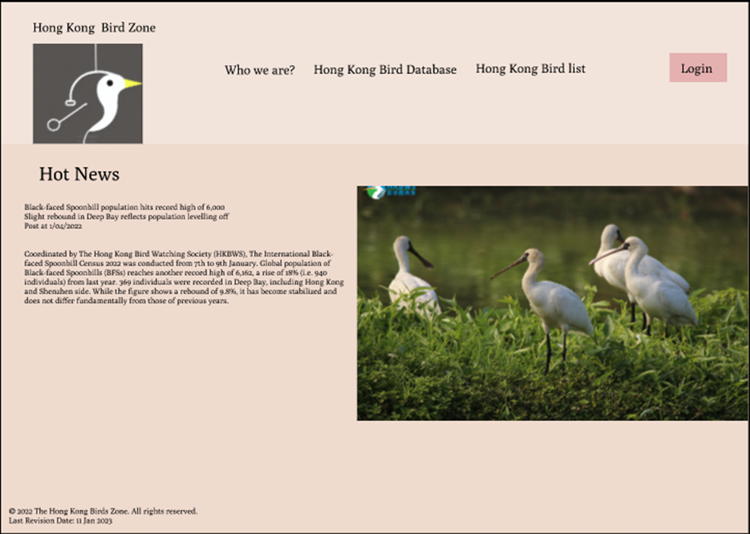

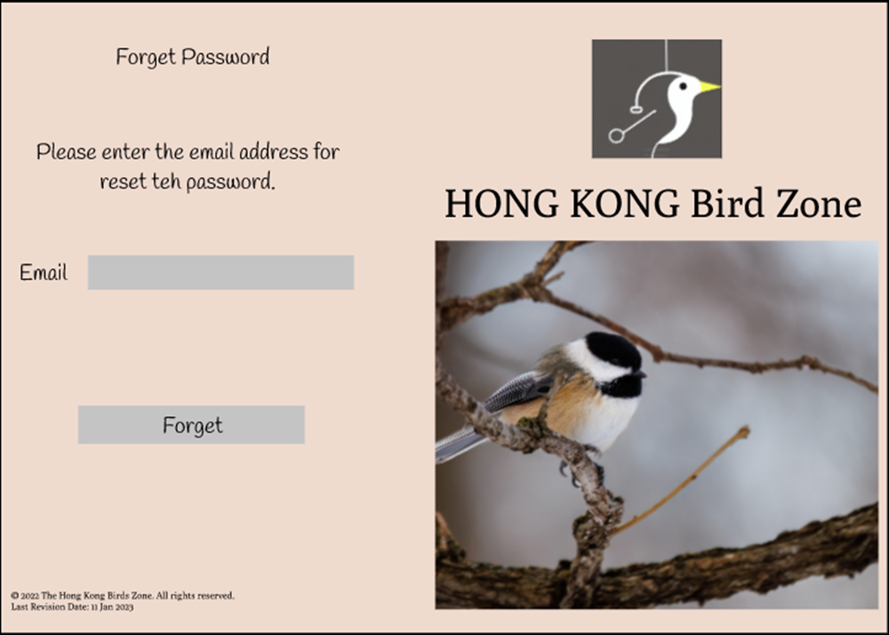

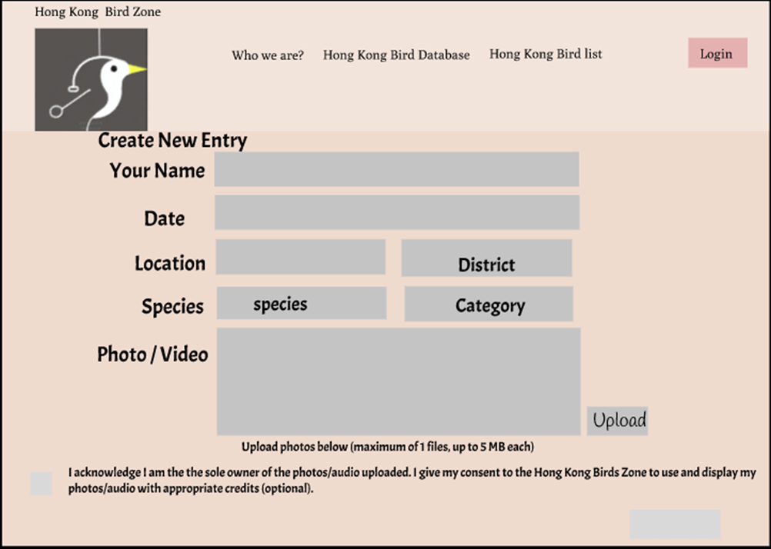

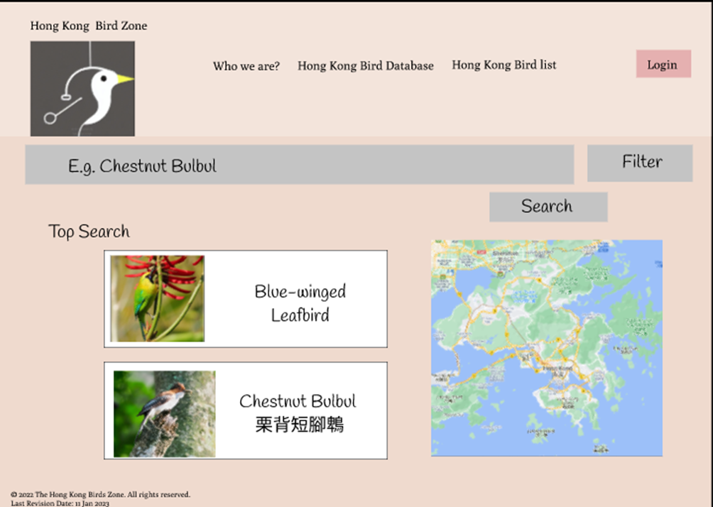

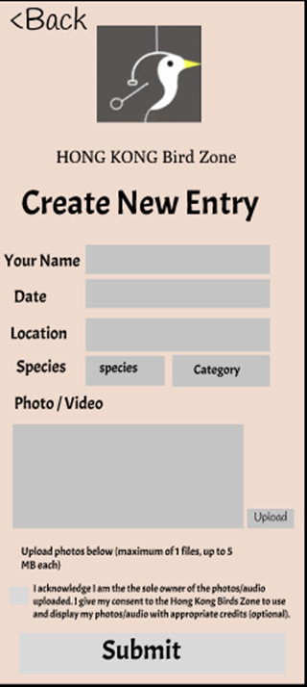

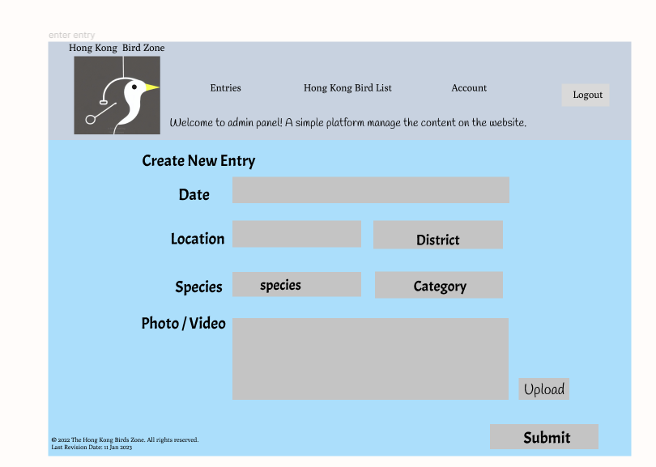

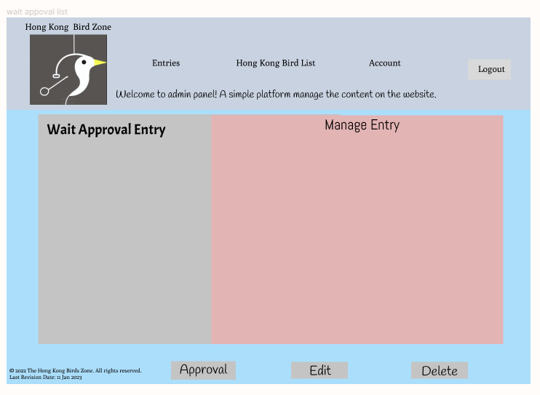

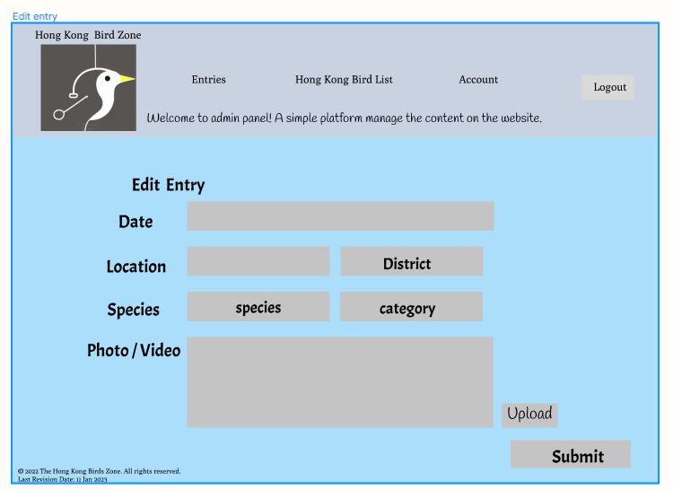

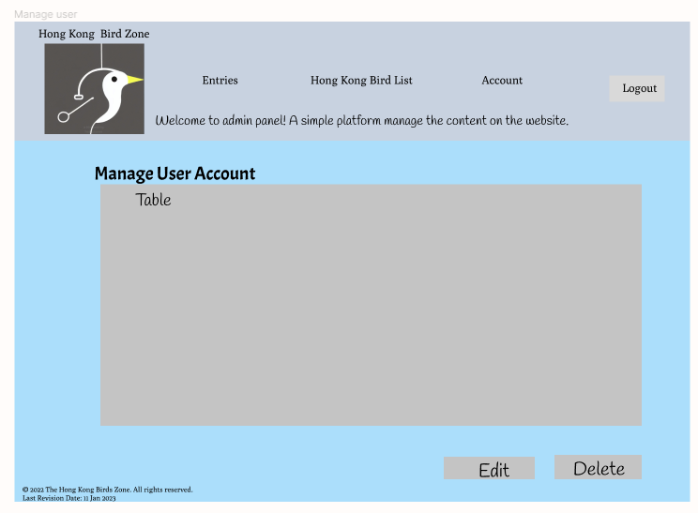

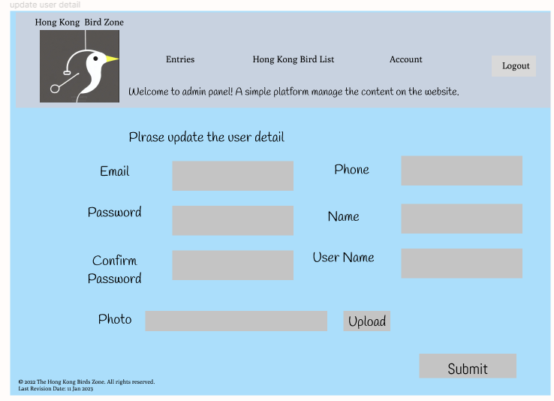

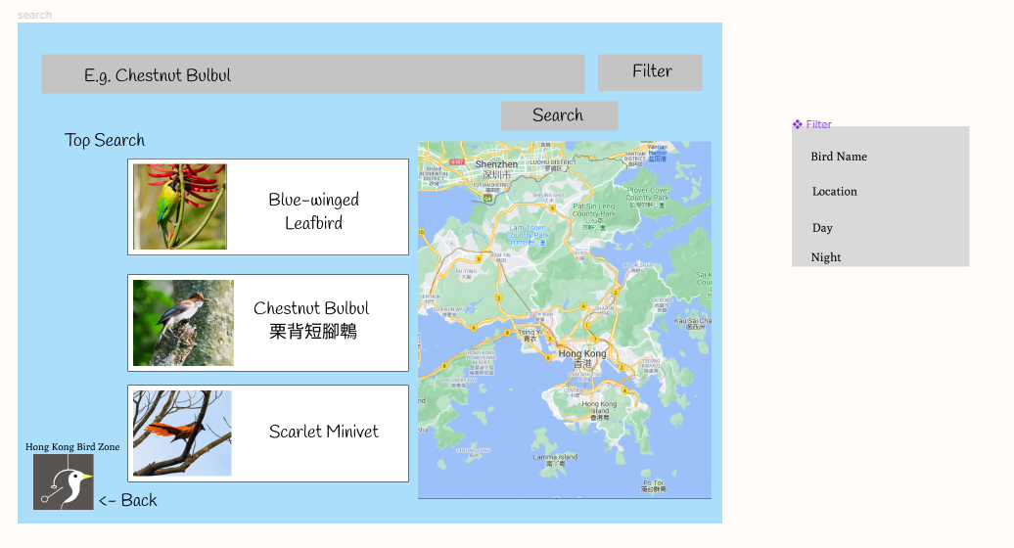

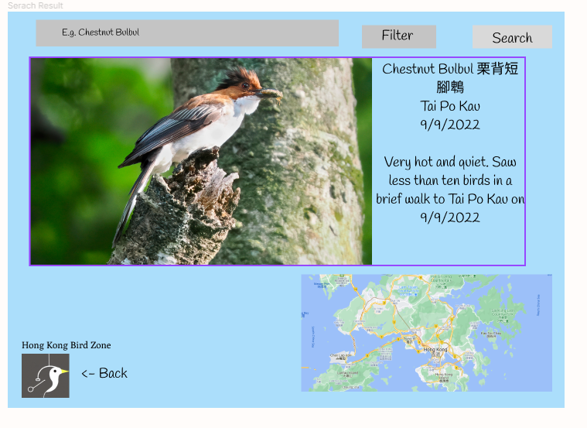

Figma Link:

https://www.figma.com/file/uVwAs3Y53n0QY3DugSIomK/Bird?node-id=0%3A1&t=YwZo82g5FquvIVFZ-1

1. The progress up until the marketplace demo

Until 12 Jan 2023, we have completed the Phase 1 – Planning stage and Phase 2: Content stage. We are currently in Phase 3 – Design stage.

